## Obstacle Sensor

The obstacle sensor is just as easy to use as the sound sensor. The wiring job is shown below. Here we connect the output from the module to the Arduino digital pin 7, and of course GND to GND and VCC to 5V.

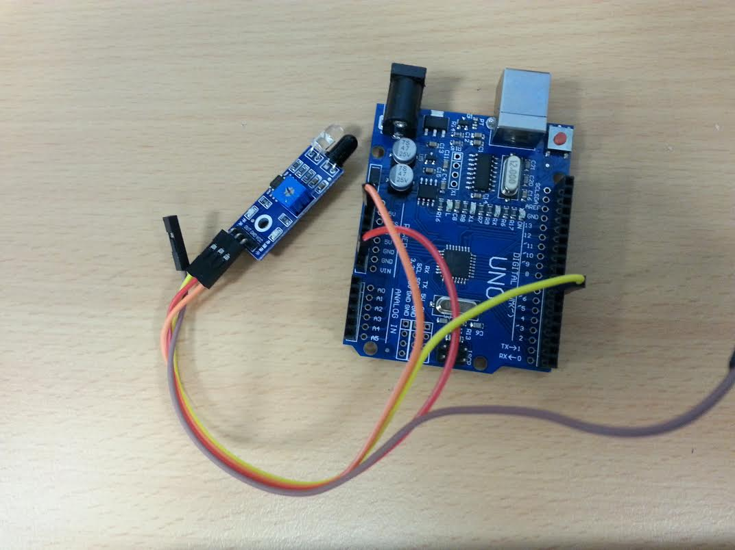

Like the previous module we have an input pin (we connect this one to digital 7) and when this is dropped low, the sensor has detected something, in this case: an object. Here, when we detect an object, we alert the user using the the serial monitor (covered in previous module examples).

//connect OUT pin to digital 7, gnd to gnd and vcc to 5v

int isObstaclePin = 7;

void setup() {

pinMode(isObstaclePin, INPUT);

Serial.begin(9600);

}

void loop() {

if (!digitalRead(isObstaclePin))

Serial.println("obstacle detected");

delay(200);

}